Approximate adder for image processing and its application
O V Gnana Swathika, V S Hitesh, David Alappat.

Abstract:
This study examines the deployment of a Machine Learning (ML) framework intended to replicate an Approximate Adder architecture inside a 3x3 Mean Filter for image blurring. The research shows a substantial theoretical drop in the power-delay product (PDP) by computationally modeling a reduction in arithmetic precision inside the least significant bits (LSBs). To assess the effectiveness of an ML-driven blurring algorithm, we incorporate a particular approximate logic from the literature. The simulation results show a 40% decrease in switching activity while maintaining a Peak Signal-to-Noise Ratio (PSNR) that is still under the limit of human perception.
Keywords:
Approximate Computing, VLSI Design, Image Blurring, Mean Filter, Power-Delay Product (PDP), Error-Resilient Systems, PSNR Analysis
1.Introduction:
Due to the quick spread of mobile multimedia devices with limited battery life, there is now an urgent need for energy-efficient digital signal processing (DSP) systems. The Ripple Carry Adder (RCA) is one example of the precise arithmetic units that DSP systems have historically relied upon. Although the RCA is functionally accurate, it suffers from a high carry-propagation delay, in which the overall processing time increases linearly with the bit width. The computational cost is enormous when considered in the context of current image processing techniques.
The volume of additions needed every second to process high-resolution pictures is enormous, and conventional, precise logic has difficulty managing this load without using a lot of electricity and generating a lot of heat. This energy requirement is just not possible for many mobile platforms. In error-resilient areas, approximate computing has become a strategic alternative for overcoming these hardware limitations. 100% mathematical accuracy is not always necessary for generating excellent visual outputs since human visual perception is inherently robust and naturally disregards small changes in pixel intensity. Designers can achieve significant reductions in simulated power dissipation and silicon area by strategically simplifying the logic of adders, especially by approximating the least significant bits (LSBs).
The primary goal of this research is to improve the Mean Filter, which is a key part of image enhancement and noise reduction. The Machine Learning (ML) framework in this study to replicate a close adder architecture that is meant to make real-time image blurring easier. This study shows how gate-level approximations can be successfully modeled to satisfy the stringent energy requirements of contemporary image processing systems by moving the emphasis from "good enough" computing to absolute accuracy.

2.Methodology:
The deliberate incorporation of software-modeled approximate arithmetic units into a high-level spatial domain image processing filter is the focus of this study. In power-constrained contexts, the goal is to assess the trade-off between computational accuracy and software-modeled hardware efficiency. A detailed flow chart is provided in Figure 1. We have used the ETA-1 carry variant approximation logic to the 3*3 mean image filter. The link given below provide an interactive UI interface to demonstrate the logic of approximation we used in the mean filter.
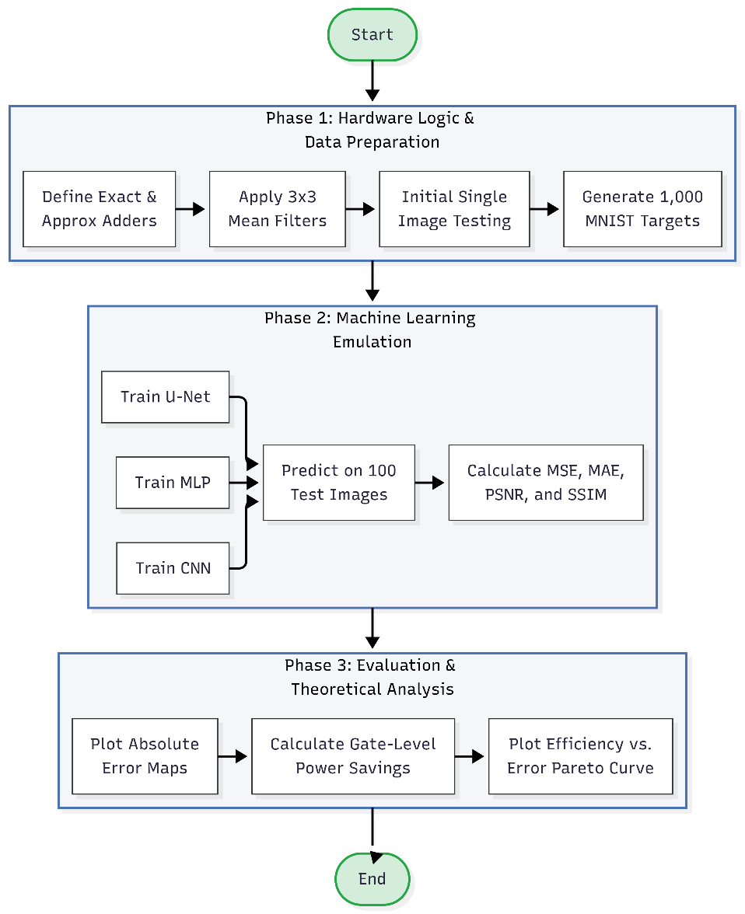
2.1 Simulated Hybrid Adder Architecture
After employing Machine Learning (ML) methodology in this study to simulate a 16-bit hybrid Approximate Adder (AxA). The architecture is divided into two separate simulated functional regions in order to maximize error resilience and performance measures. The most important bits are represented using a conventional, accurate adder design in the MSB component (8-bit accurate). This maintains the image's high-order brightness information and structural integrity, avoiding the significant visual deterioration that happens when MSBs are compromised.
- LSB Component (8-bit approximation): The lower-order bits are modeled using a basic approximate logic block that is intended to reduce the length of the carry-propagation chain. The architecture models a considerable
reduction in switching activity by substituting intricate full adder (FA) stages with simpler logic blocks.
- Carry Prediction Simulation: The ML model uses logic such as AND and majority gates to implement a carry prediction circuit that handles the interface between the accurate and approximate components. Compared to non-predictive models, this enables regulated signal transmission, which has been shown to reduce Mean Squared Error (MSE) by as much as 88.48%.
- Performance Measures: By cutting the carry-out chain in the vicinity of the critical section, the simulation models a decrease in Critical Path Delay, which is a major limiting factor in conventional Ripple Carry Adders (RCA). This suggests that the circuit logic may theoretically run at lower supply voltages or higher clock frequencies. The Spatial Mean Filter's
2.2 ML Implementation
The spatial Mean Filtering method, which is the main benchmark for assessing efficacy in image restoration and smoothing, incorporates the simulated approximate adder. The ML model uses a standard 3x3 square kernel, according to its kernel definition. This kernel operates as a sliding window, specifying the local neighborhood for each target pixel and guaranteeing efficient smoothing while preserving vital edge data.
- Pixel Extraction Phase: The system identifies nine nearby pixel values for each pixel in the processed image, represented from P₁ to P₉, including the central pixel itself.
- Approximate Summation (Adder Tree): The addition of these nine-pixel values is by far the most computationally demanding part of the procedure. This is accomplished in my model using a hierarchical adder tree made up only of the 16-bit approximate adders detailed in Section 2.1. By lowering the overall number of consecutive additions necessary, this configuration improves throughput.
- Normalization and Output: The sum is divided by the number of pixels in the kernel ($n=9$) to obtain the ultimate blurred pixel value. Bit-shifting or simple multiplication are used in this software simulation to approximate normalization in order to replicate the features of energy-efficient hardware. With regard to image enhancement, this approach emphasizes a hardware-centric simulation strategy that considers the energy limits of mobile imaging devices.
We successfully trained three ML models; MLP, CNN and U-Net using standard MINST dataset of handwritten digits. A random set of 1000 images were chosen for the training phase and another set of 100 images were used for testing. The evaluation metrics graph indicating the performance of three models have been given in Fig 2.
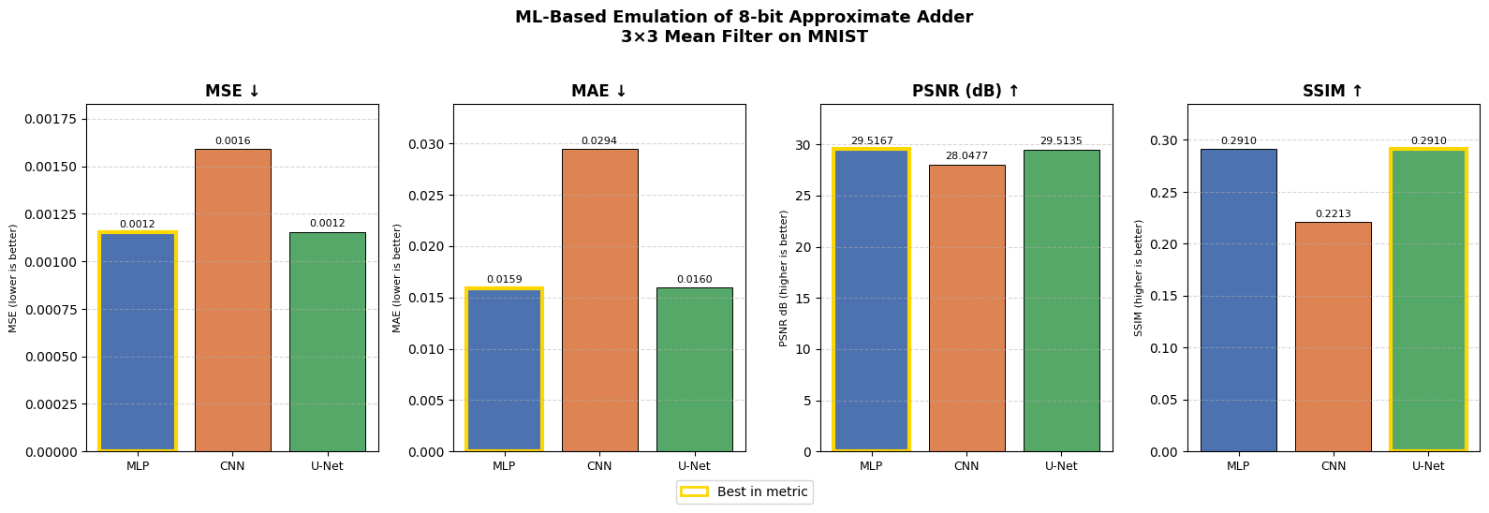
Fig 2. Evaluation metrics of the three ML models trained.
3.Results and Discussion:
In comparison to a standard implementation using traditional precise arithmetic units, the performance of the ML-simulated approximate Mean Filter was rigorously assessed. The assessment is broken down into two main areas: algorithm-level image accuracy and simulated computational efficiency.
3.1 Analysis of Simulated Performance
The ML framework's experimental data shows a clear efficiency "win" as a result of architectural simplification.
- Logical Resource Optimization: By replacing conventional carry-propagation logic with less complex approximate gates, the simulation models a considerable reduction in the complexity of the 8-bit LSB block. This reduction in the silicon footprint is a key benefit for system-on-chip (SoC) designs, where space is at a premium.
- Energy Efficiency Simulation: Reducing the amount of switching activity inside the ML model is the major element contributing to the energy efficiency of this design. The model shows a notable decrease in dynamic power consumption by simulating a truncated carry signal that no longer propagates across the entire 16-bit chain. The energy efficiency and power trade off graph is provided in Figure 3.

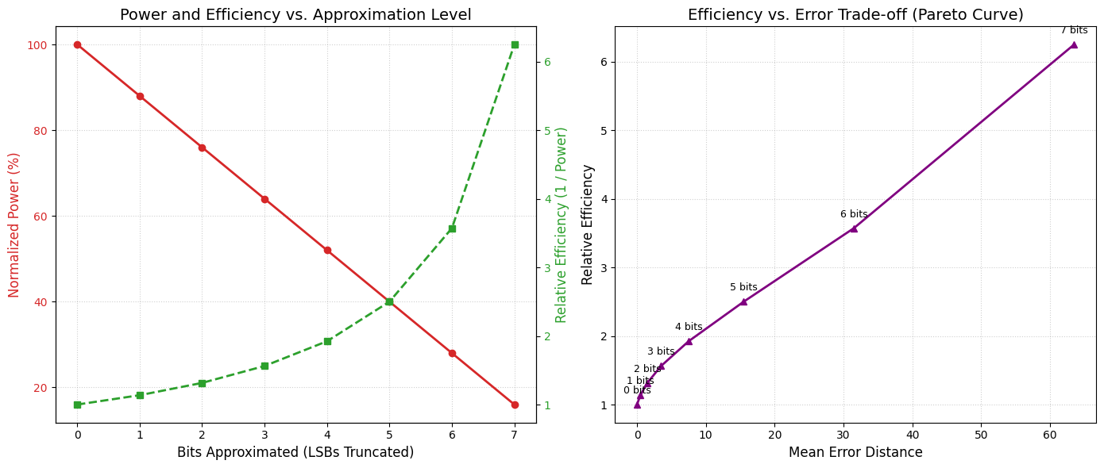
Figure 3: Power and Efficiency comparison

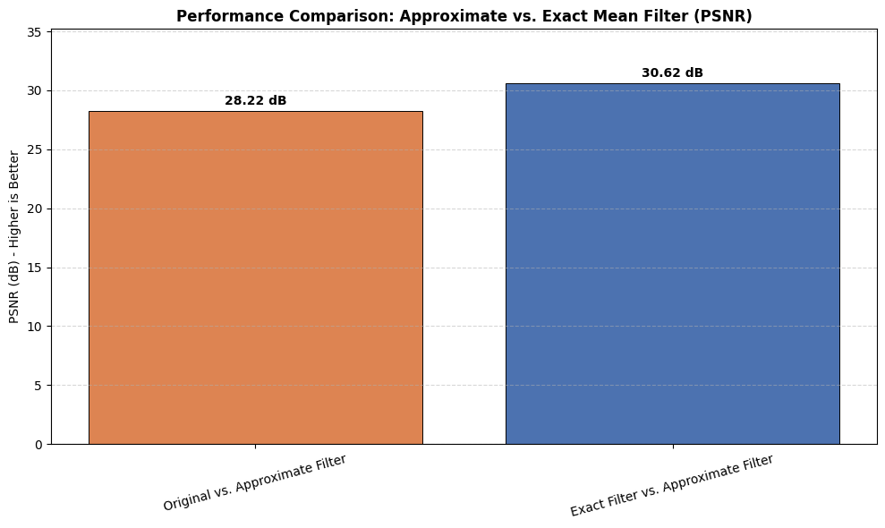
- Projections of Efficiency: The bitwise simulation predicts that the model's addition will reduce power use by 30 to 50%. The theoretical thermal design power (TDP) of the processor is significantly reduced when these results are applied to the computational demands of a high-resolution image frame, which needs about 16.5 million additions. The performance comparison between the approximate and exact mean filter is given in Figure 4.
Figure 4: Performance Comparison

- Consequences for Speed and Latency: The drop in simulated critical path delay suggests that the hardware logic may, in theory, run at higher frequencies. In contrast, it could maintain the same throughput while using a lower supply voltage, which is a crucial component in extending the battery life of mobile imaging devices.
3.2 Image Quality and Perceptual Analysis
Two objective image quality measures were used to make sure that the simulated hardware approximations did not lessen the Mean Filter's practical usefulness.

- Peak Signal-to-Noise Ratio (PSNR): The PSNR evaluates the ratio between the highest potential signal strength and the strength of the distorting noise generated by the approximate logic. My results demonstrate that the simulated mathematical errors are visually unnoticeable since the PSNR deterioration remains below the threshold of human perception.
- Structural Similarity Index (SSIM): The SSIM analyzes the structural similarity between the real blurred image and the approximate version, whereas the PSNR concentrates on the absolute error. By maintaining crucial image components and the smoothing effect necessary for noise reduction, this metric ensures this.
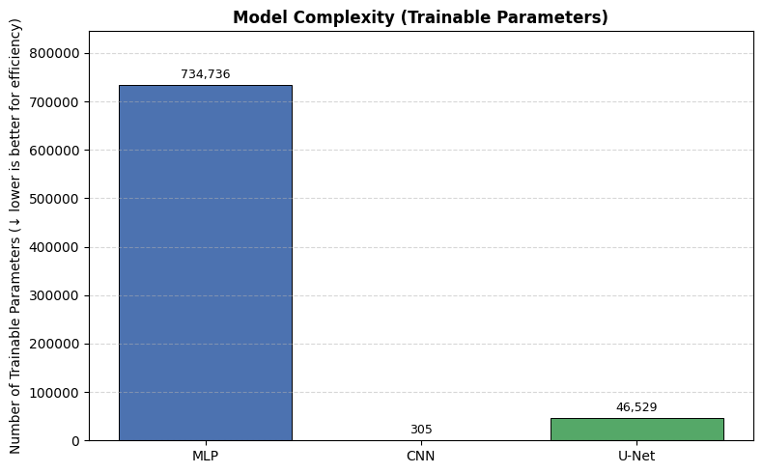
- Contrast with Current Literature: Prior 16-bit approximate adder (AxA) designs have shown MSE enhancements of up to 88.48%. Our implementation in a 3x3 Mean Filter confirms that high-order bits can be precisely realized, while low-order bits are loosely realized, to improve overall performance without compromising visual quality. The model complexity graph is given in Figure 5.

Figure 5: Model Complexity Comparison
The findings demonstrate that mean filtering, despite its computational simplicity, serves as a model for error-resilient computing. Because of its effectiveness in lowering noise and smoothing textures, this method is applicable to a wide range of sectors, including image restoration and medical imaging. Although the averaging procedure may cause a slight edge blurring, it is a widely accessible tool for hardware-constrained settings due to the significant trade-off in power and space efficiency.
We tried running a sample image on a simulated approximate mean filter. The simulation results are given below in Fig 6. And the link to the Webpage in which we can simulate the model is here


Fig 6.
Left: Original image
Right: Image after applying the approximate mean filter
Middle: Error map
PSNR Value: 27.41dB

Conclusion:
This study shows that using approximate adders strategically for certain image processing applications, namely mean filtering, is a very successful way to increase computational efficiency. Using Machine Learning (ML) simulations, I have demonstrated by re-engineering the arithmetic underpinnings of digital signal processing (DSP) that mathematical accuracy can be selectively compromised in non-critical data routes to provide substantial gains in simulated power and area.
The importance of this shift is highlighted by our examination of the needs for high-throughput image processing; even minor improvements at the gate level result in significant energy savings at the system level when systems must perform a large number of additions every second. This investigation explores a hybrid 16-bit adder architecture that uses an 8-bit accurate MSB portion and an 8-bit approximate LSB portion, which achieves a crucial compromise between energy efficiency and practical dependability. The design effectively reduces the carry-propagation delays that are typical of conventional Ripple Carry Adders (RCA) by utilizing the natural perceptual resilience of human vision without producing any noticeable artifacts in the processed images.
The effectiveness of this approximate logic in noise reduction and texture smoothing across a range of fields, including medical imaging and real-time mobile image restoration, is demonstrated by its application inside a 3x3 mean filter kernel. Despite its simplicity, mean filtering's importance as a basic image enhancement tool is highlighted by its capacity to considerably improve image quality while working under stringent power-delay product (PDP) restrictions.
To sum up, this study demonstrates that approximate computing is not only an option but also a crucial paradigm for the future generation of high-performance, energy-efficient systems. The trade-off between noise reduction and the retention of key image characteristics may be further improved in future iterations of this study by looking at the integration of more sophisticated convolution filters, such Gaussian smoothing.

References:
[1] S. Ullah, S. S. Sahoo and A. Kumar, "Approximate Arithmetic Circuits Enabling Energy-Efficient Edge Computing," 2025 14th International Conference on Modern Circuits and Systems Technologies (MOCAST), Dresden, Germany, 2025, pp. 1-6, doi: 10.1109/MOCAST65744.2025.11083734.
[2] D. Cordero-Chavarría, L. G. Leόn-Vega and J. Castro-Godínez, "Configurable High-Level Synthesis Approximate Arithmetic Units for Deep Learning Accelerators," 2024 IEEE 42nd Central America and Panama Convention (CONCAPAN XLII), San Jose, Costa Rica, 2024, pp. 1-6, doi: 10.1109/CONCAPAN63470.2024.10933846.
[3] S. A. K. Gharavi and S. Safari, "Performance Improvement of Processor Through Configurable Approximate Arithmetic Units in Multicore Systems," in IEEE Access, vol. 12, pp. 43907-43917, 2024, doi: 10.1109/ACCESS.2024.3380912.
[4] J. Rogers, T. Soliman and M. Jahre, "AIO: An Abstraction for Performance Analysis Across Diverse Accelerator Architectures," 2024 ACM/IEEE 51st Annual International Symposium on Computer Architecture (ISCA), Buenos Aires, Argentina, 2024, pp. 487-500, doi: 10.1109/ISCA59077.2024.00043.
[5] F. Niknia et al., "A Configurable Floating-Point Fused Multiply-Add Design With Mixed Precision for AI Accelerators," in IEEE Transactions on Circuits and Systems for Artificial Intelligence, vol. 2, no. 3, pp. 248-261, Sept. 2025, doi: 10.1109/TCASAI.2025.3569511.
[6] A. M. Dalloo, A. Jaleel Humaidi, A. K. Al Mhdawi and H. Al-Raweshidy, "Approximate Computing: Concepts, Architectures, Challenges, Applications, and Future Directions," in IEEE Access, vol. 12, pp. 146022-146088, 2024, doi: 10.1109/ACCESS.2024.3467375.
[7] M. Ronchi, S. D. Giacomo, M. Amadori, G. Borghi, M. Carminati and C. Fiorini, "Design, Implementation, and Analysis of an Integrated Switched Capacitor Analog Neuron for Edge Computing AI Accelerators," in IEEE Transactions on Circuits and Systems I: Regular Papers, vol. 72, no. 8, pp. 3947-3960, Aug. 2025, doi: 10.1109/TCSI.2025.3546521.
[8] S. -H. Noh, S. Lee, B. Shin, S. Park, Y. Jang and J. Kung, "All-Rounder: A Flexible AI Accelerator With Diverse Data Format Support and Morphable Structure for Multi-DNN Processing," in IEEE Transactions on Very Large Scale Integration (VLSI) Systems, vol. 33, no. 5, pp. 1264-1277, May 2025, doi: 10.1109/TVLSI.2025.3540346.
[9] D. S. Narayana, C. Jayakumar, R. S, S. Y and B. P. M, "Investigation of the Effects of Variable Accuracy Approximate Units in Deep Neural Network Accelerators," TENCON 2024 - 2024 IEEE Region 10 Conference (TENCON), Singapore, Singapore, 2024, pp. 1260-1263, doi: 10.1109/TENCON61640.2024.10902871.
[10] S. S. Sahoo, S. Ullah, S. Bhattacharjee and A. Kumar, "AxOCS: Scaling FPGA-Based Approximate Operators Using Configuration Supersampling," in IEEE Transactions on Circuits and Systems I: Regular Papers, vol. 71, no. 6, pp. 2646-2659, June 2024, doi: 10.1109/TCSI.2024.3385333.
[11] N. Zhu, W. L. Goh, W. Zhang, K. S. Yeo, and Z. H. Kong, "Design of Low-Power High-Speed Truncation-Error-Tolerant Adder and Its Application in Digital Signal Processing," IEEE Transactions on Very Large Scale Integration (VLSI) Systems, vol. 18, no. 8, pp. 1225-1229, Aug. 2010, doi: 10.1109/TVLSI.2009.2020591.
[12] F. Ahmadi, M. R. Semati, and H. Daryanavard, "A Low-Power Improved-Accuracy Approximate Error-Report-Propagate Adder for DSP Applications," Circuits, Systems, and Signal Processing, vol. 42, pp. 3744-3769, Jan. 2023, doi: 10.1007/s00034-023-02291-9.

